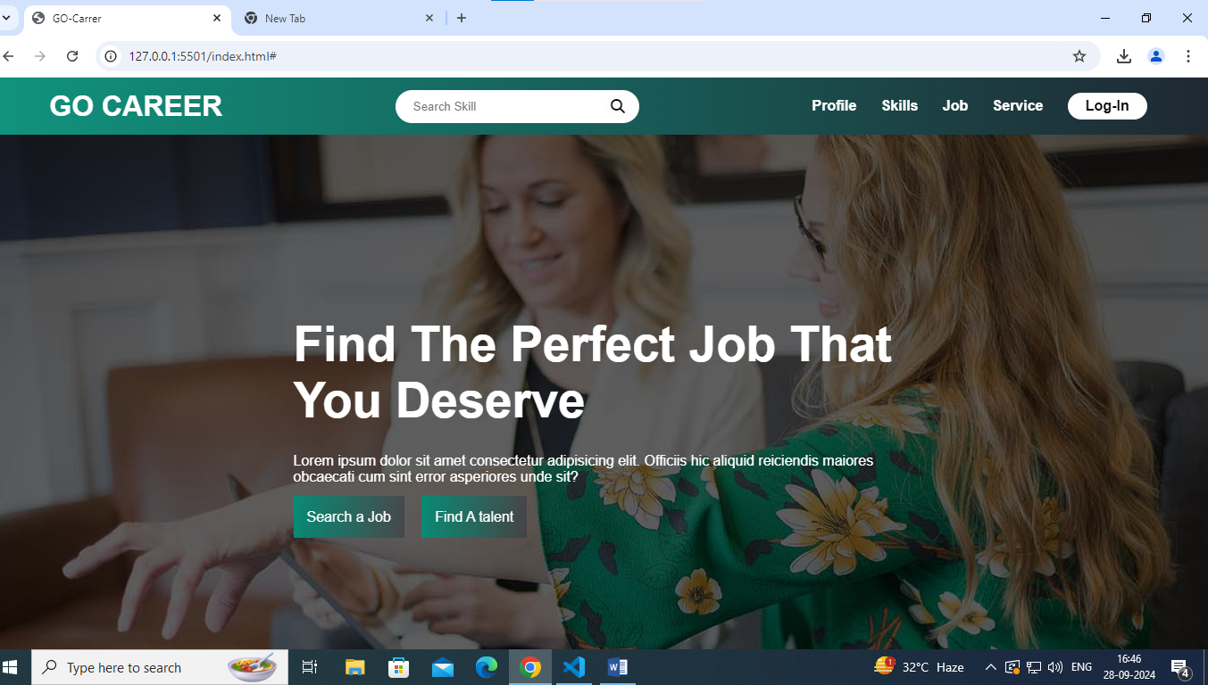

STEP1:- CREATED A NAV-BAR IN CREATING NAV-BAR I’VE USED A SEARCH ICON FROM THE FONT AWESOME USING THE CDN OF FONT AWESOME.

IN THE HERO SECTION I’VE USED A BACKGROUND IMAGE FROM GOOGLE SEARCH

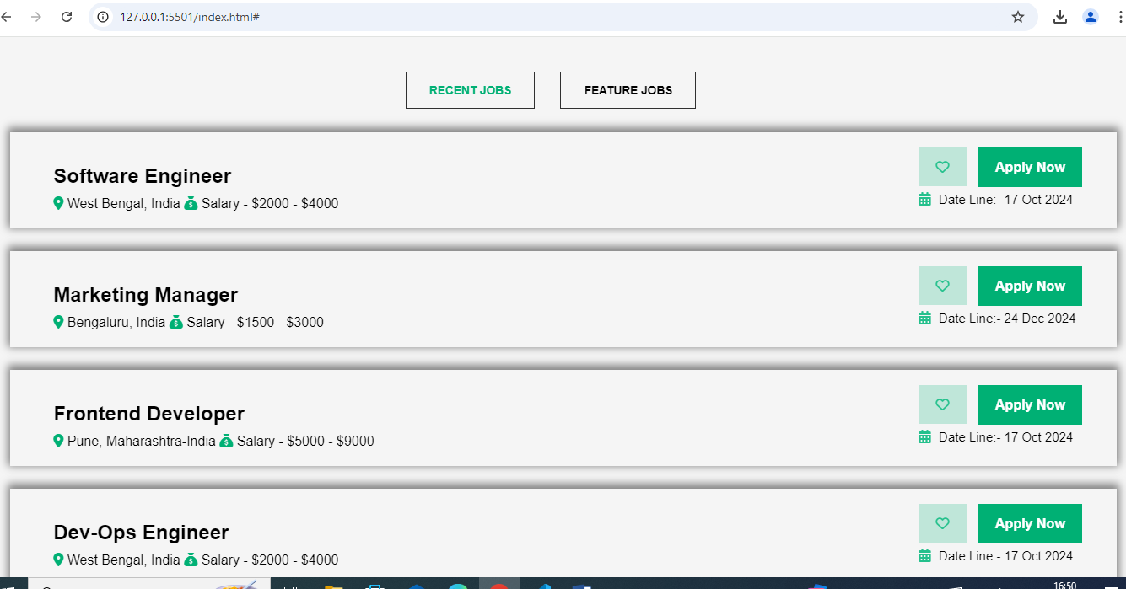

IN THIS PAGE I’VE USED THE ICON FROM FONT AWESOME WEBSITE

AND I’VE CREATED A NAMED “BROWSE MORE JOBS” BUTTON USING UI VERSE

AND FOR SMOOTH SCROLING AND ANIMATION I’VE USED LOCOMOTIVE AND GSAP. USING ITS CDN.